1) Setup jenkins CICD pipeline using freestyle job using Docker containers using below code.

https://github.com/betawins/hiring-app.git

Stages:

1. Git Clone  
   A screenshot of a computer

   Description automatically generated  
   A screenshot of a computer

   Description automatically generated
2. Sonarqube Integration  
   A screenshot of a computer

   Description automatically generated

3) Maven Compilation  
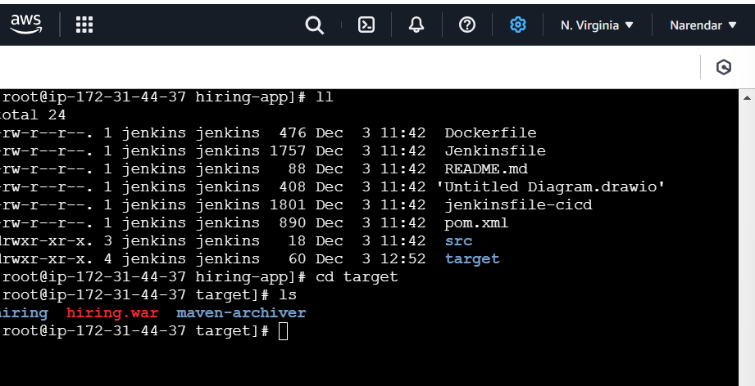

4) Nexus Artifactory

5) Slack Notification

6) Deploy On tomcat

2) Setup a jenkins CICD pipeline using Declarative pipeline using feature-1.1 branch.

https://github.com/betawins/sabear_simplecutomerapp/tree/feature-1.1

stages:

1) Git Clone

2) Sonarqube Integration

3) Maven Compilation

4) Nexus Artifactory

5) Slack Notification

6) Deploy On tomcat

3) Setup a jenkins CICD pipeline using Scripted pipeline using feature-1.1 branch.

https://github.com/betawins/sabear_simplecutomerapp/tree/feature-1.1

stages:

1) Git Clone

2) Sonarqube Integration

3) Maven Compilation

4) Nexus Artifactory

5) Slack Notification

6) Deploy On tomcat

4) Write sample skeleton of pipelines.

5) Create a parametirized job in jenkins.

https://github.com/betawins/spring3-mvc-maven-xml-hello-world-1.git

6) Setup one slave machine for jenkins.